Q&A – Chips JU 2024 non initiative calls

1. About the PO template that can be downloaded from the Funding and Tenders Portal: The usual tables to be filled in Section 3.1 (List of Work Packages, Work Package Descriptions, List of deliverables, List of Milestones, Critical risks, etc.) are currently missing from the template. Does it means that these table are not needed for the PO application? Or do we expect an update on the template to have these tables back?

* At the PO phase we do not require this level of detail. The PO phase is mainly evaluated on the innovation and impact.

1. Regarding the Joint call with Korea (HORIZON-JU-Chips-2024-3-RIA). This call sounds interesting and appropriate for the technology we are developing. However, I cannot find any information regarding the details and what the call is about. It is mentioned on the European Commission website to refer to the "Amended Chips JU Work Programme 2023-2027" which I don't find and where the only PDFs available cannot be opened. Can you please share with me the relevant resources?

* You can find all the information on our website on the page: <https://www.chips-ju.europa.eu/mawp/>
* The Korean call is a non-initiative call 2024 and therefore go to appendix 3 and the Korean call is describe on page 69

1. In the ECS Brokerage Event in Brussels last week, the CHIPS JU showed the following overview of the Chips JU calls:

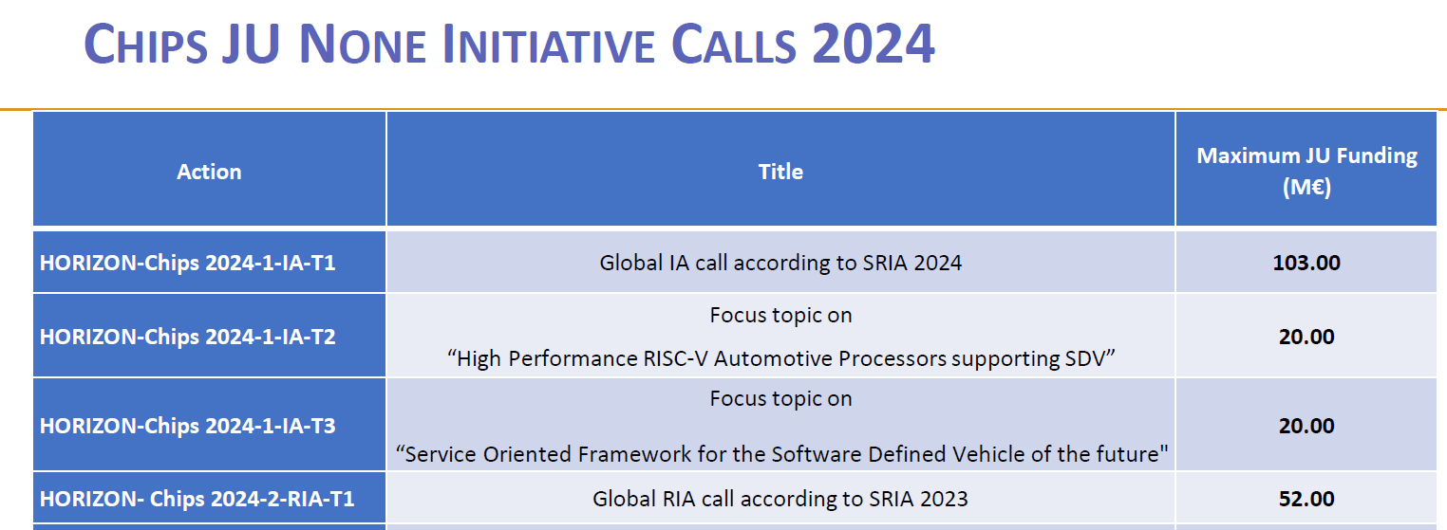

Usually, there is some information about the expected contribution per project, would you please be so kind at to tell me how many projects will be funded and how much contribution from the Commission is expected for individual projects in these 4 calls of the screenshot.

* Please note that those calls are nt managed by the Commission but by the Chips JU. For the first and last calls in the table, those calls invite proposals of any size. For the 2nd and 3rd focus topics there 1 project per call is expected.

1. Our university is submitting a project for the Joint call with Korea on Heterogeneous integration and neuromorphic computing technologies for future semiconductor components and systems ( HORIZON-JU-Chips-2024-3-RIA). We need few clarifications:

* shall I include in the form A all the partners of the consortium, both from EU and Korea (using their PIC)?
* Yes please the Korean should get a PIC from the portal but no need for validation and with that you can include them as associated partner
* regarding the National Budget Table that must be uploaded on the Funding and Tender Portal, shall I include in the table all the members of the consortium from EU and Korea?
* Yes please, please include costs if possible
* in the National budget Table, what shall I write in the box (H) Requested Grant/€ for Korean partners?
* 0 Euro.

1. In preparation of an application for the Call HORIZON-Chips-2024-3-RIA: Joint call with Korea it is not very clear if:

Option A: the EU consortium prepares a proposal in English, with objectives, tasks and deliverables carried by the European partners only. The EU proposal is then submitted to Chips JU. In parallel, the Korean consortium prepares a proposal in Korean, with objectives, tasks and deliverables carried by the Korean partners only. The Korean proposal is submitted to NRF. In the two different proposals, synergies between the consortium are described.

Option B: the EU consortium and the Korean consortium prepare together a unique proposal, where some WPs are led by European partners, some WPs by Korean partners. The unique proposal is submitted both to the Chips JU, and to the NRF. Could you please clarify?

* The option B reflects the way to proceed for such application. The choice of organizing the WPs by country/regions is at the discretion of the consortia or participants.

1. Regarding Chips-JU-2024-3-RIA (joint Korean call) we would like to verify the following information.

The proposal template from the Korean side states the following:

Total Research Period (July 2024 to June 2027 / 36 months)

* First Year: **July 2024** to December 2024
* Second Year: January 2025 to December 2025
* Third Year: January 2026 to December 2026
* Fourth Year: January 2027 to June 2027

If projects are supposed to start in July 2024, the time frame between submission deadline (= 14 May 2024) and project start are extremely tight; could you please clarify?

* The project can start in July 2024 before the signature of grant agreement, if needed, or rather after the signature of the grant agreement.
* The research dates indicated in the proposal template from the Korean side reflect the South Korean Research National Foundation time-window periods for the Korean participants.
* The projects at matters are joint cooperation projects carried with South Korean counterparts. Therefore, it is supposed that the European participants are in talks with their Korean counterparts or project partners, including on synchronization on project timing, or for planning different starting time under the umbrella of the joint project, depending on the specificity of tasks and/or actions of each participant.

1. Concerning the scope of the joint call with South Korea, could you give us more detail about “beyond silicon” innovation scope defined within the joint call with South Korea? Are combinations of electronics and photonics encouraged – or are explorations in new, possibly experimental, materials encouraged as direct / alternative innovations to silicon?

* Regarding photonics, as outlined in the scope of the call, the proposals should address research reaching TRL 4 in the design, fabrication process and/or packaging segments of the micro-nano- electronics or photonics value chain and their related integration technologies. Both combinations of electronics and photonics and explorations in new materials are in scope of the call.

1. Concerning the letter of intent of the joint call with South Korea, is there specific expectations/requirements/guidelines for the content and format of the letter of intent between EU and ROK consortia?

* The letter of intent should reflect the willingness and commitment of the European entities and their Korean counterpart to collaborate on the same type of action, although on different intertwined tasks.

1. Regarding the EU-ROK joint call, I would like your help with:

* Format/template for letter of intent: kindly provide us with a template that we can quickly circulate amongst the partner and get it signed.
* If I understand correctly this letter of intent will be only for us to collect form European partners for EU side of submission. Do we also need letter of intent signed by Korean partners that needs to be submitted by EU side? If so, is there a different format for the Korean Partners to sign?
* Where do we include this letter of intent? within the application (where would it be suitable) or is there a separate place to upload it?
* There is not a template for such letter of intent. We let it to you and your Korean counterparts to produce such a letter. Please find below a guideline to help you drafting such letter.



* The letter of intent should be signed by both EU and ROK partners and state the intention and the commitment of both parties to collaborate under the umbrella of the submitted joint project proposal, in case the proposed joint project will be selected.
* The letter of intent should be uploaded with the application.

1. Dear Team Calls, while becaming aware of the joint call with Korea, we were looking at ways to become part of consortia within this call. To this end, we found the “Partner search announcement” feature rather useful. However, we were not able to find out how we can add an item explaining our expertise to the database. Could you explain to us how this is done?

* Please follow the link below to find how you can add an item to advertise your interest.

<https://webgate.ec.europa.eu/funding-tenders-opportunities/display/IT/Find+partners#Findpartners-AddaPartnerSearchannouncement>

* In case you would encounter any issue, we would invite you to contact the help desk. Here below you can find the link:

<https://ec.europa.eu/info/funding-tenders/opportunities/portal/screen/support/helpdesks/contact-form>

1. Concerning the budget of the joint call with South Korea, given the EU total expenditure set at €6 million for potentially 6 projects – plus the mention of a typical action expecting €1.5 million, is there a particular expectation/recommendation on this point, especially the balance to find between ambition to align with the call’s objectives as much as possible versus keeping a relatively limited budget?

* Notwithstanding that the budget per type of action will depend on the content and quality of the submitted proposals and the outcome of the evaluation process against the established criteria, we estimate that a typical action for this call might be around €1.5 million .

1. Regarding the EU-ROK joint call, I do have a question, as it states that it needs to be at least 3 partners highlighted in yellow in the Appendix 3 document. Is there a requirements, where this 3rd partner needs to be? Also, do we need a Research Institute as a partner? or can we be a SME and a bigger company? Is there any chance to screen our project idea with someone upfront?

* The 3 partners should be 3 organizations from 3 different participating countries of the CHIPS JU with at least one organization of those 3 from a member state of the European Union (the coordinator)
* Targeted  project partners for the call are universities, Research & Technology Organisations, SMEs (small and medium enterprises) and large companies able and interested to perform low TRL research. Therefore, any of the entities you mention could be part of the EU consortium (e.g.  in case of 3 participants from the EU side these could be 3 research institutes, or 3 SMEs or 3 bigger companies or any other possible combinations of these types of entities such as 2 SMEs and 1 research institute, etc…)
* There is not such possibility, namely screening project ideas upfront with us is not possible

1. As we are preparing our submission for the upcoming HORIZON-JU-Chips-2024-3-RIA call, we would like some help in clarifying the expected outcomes of the project.

As per  APPENDIX 3: ACTIVITIES LAUNCHED IN 2024 FOR THE NON-INITIATIVE PART the expected outcomes are stated as :

* New materials, process, device, integration and design concepts for neuromorphic computing systems supporting very low energy consumption, connectivity and embedded functions for mobile applications
* Alternative manufacturing process technologies for semiconductor chips including frontend or backend for heterogenous integration. The technologies should sustain in the mid- and long-term the fast paced evolution of device performance, miniaturisation and cost, while reducing the environmental footprint. This includes the process of integrating individually produced chip components into a single assembly level, as well as solutions to streamline and improve this process
* Advanced packaging solutions aiming at heterogeneous integration of multiple functions and materials for applications in AI, communication (RF, mmW or THz), sensing, actuating, power management and active/passive device integration

However in  page 71 it is stated in the Evaluation criteria:

Credibility of the pathways to achieve the expected outcomes and impacts specified in the ECS SRIA 2024, and the likely scale and significance of the contributions to the project.

However the ECS SRIA 2024 is a rather extensive document covering several technological aspects.

Can you comment if there is a more limited scope, included in the ECS SRIA 2024, that  the proposal is aimed at ? Or does this refer only to above expected outcomes?

* The expected outcomes of this specific call as indicated in Appendix 3 and as per the technology aspects mentioned in such Appendix should contribute to and  be in line with the ECS SRIA 2024 relevant outcome and impacts.

1. I need further information regarding the eligibility criteria in order to participate in the 2024 Non-Initiative Calls for the Chips-JU Partnerships. I would like some clarification on how this partnership works. If Spanish funding agencies (AEI and MAEDT) are not participating, are Spanish research centers eligible for funding at any on the 2024 Non-Initiative Calls?

* This question refers to the non initiative calls 2024 Spanish participants are eligible for EU funding, for national funding you have to contact the national authorities

1. The question is “would UK entities be eligible to the new call”?I am wondering if UK applicants are eligible in the joint call with South Korea.I understand that non-EU countries are eligible as long as they are associated to Horizon Europe and/or to DEP which are the two financing programmes of the JU calls.The UK is associated to HE.

* Yes, UK organizations can participate in the call with Korea as they are eligible for EU funding under HE (associated country).

1. I have a question about this call:Topic 2 Focus topic on “High Performance RISC-V Automotive Processors supporting SDV” HORIZON-JU-Chips-2024-1-IA-T2

What are the list of associated countries outside EU member states that are eligible for applying ? In particular; are Egypt or/and Israël eligible?

* Those are non-initiative calls, therefore associated countries can participate and will get EU funding. Israel is also a participating state to the Chips JU and therefore participants from Israel could also get national funding.